# Python Essentials for MLOps

## Week 1: Introduction to Python

Given my expertise in python I simply did the labs and quizzes in this week.

### Week 2: Python functions and classes

Given my expertise in python I simply did the labs and quizzes in this week.

## Week 3: Testing in Python

**Pytest** is a powerful testing framework in Python that allows for simple and scalable testing. It's widely used due to its simplicity and ease of use.

* Pytest uses the built-in assert statement in Python for verification of test cases. The simplicity of using plain assert statements means there is no need to remember special assertion methods. For example, you can write a test case as simply as `assert this == that`. This will check if the condition holds true, and if not, pytest will fail the test and provide a detailed report about what was expected and what was actually received.
* Pytest supports both test functions and test classes, but test functions are often preferred for their modularity and simplicity. A test function in pytest is a simple function that starts with the word 'test'. Pytest identifies these functions as tests and runs them accordingly.
* Pytest also provides powerful features for setup and teardown operations, which are necessary when tests need to be set up or cleaned up in a certain way. This can be achieved using fixtures, which are functions that pytest will run before (and sometimes after) your tests. They are used to feed some data or context to the tests.
* Another advantage of pytest is its support for parameterized testing. This allows you to run a test function multiple times with different arguments, which is useful for testing a function against multiple inputs.  
    
    
    
    
  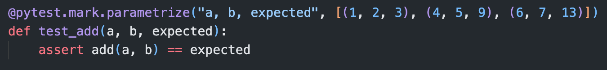

## Week 4: Introduction to Pandas and NumPy

**Pandas** is a powerful, open-source data analysis and manipulation library for Python. It provides data structures and functions needed to manipulate structured data, including functions for reading and writing data in a variety of formats.

**NumPy**, which stands for Numerical Python, is a fundamental package for scientific computing in Python. It provides support for arrays (including multi-dimensional arrays), along with a large collection of high-level mathematical functions to operate on these arrays.

## Week 5: Applied python for MLOps

**API (Application Programming Interface)**: An API is a set of rules and protocols for building and interacting with software applications. It defines methods and data formats that a program can use to communicate with other software - it's like a bridge between different software applications allowing them to work together. APIs are used in all kinds of programming from web development (where they can be used to interact with server-side software or to integrate with third-party services) to operating systems (where they provide a way for applications to interact with the operating system).

**SDK (Software Development Kit)**: An SDK is a collection of software tools and libraries that developers use to create applications for specific platforms or frameworks. An SDK might include APIs, programming tools, graphical user interface (GUI) tools, documentation, and sample code. For example, if you're developing an application for iOS, you would use the iOS SDK which provides the tools and interfaces necessary to develop, test, and deploy applications that run on Apple's iOS devices.

**Microsoft Azure**, often simply known as Azure, is a cloud computing service created by Microsoft. It provides a variety of services including those for computing, analytics, storage, and networking. Users can pick and choose from these services to develop and scale new applications, or run existing applications, in the public cloud.

**Hugging Face Transformers** is an open-source library that provides state-of-the-art general-purpose architectures (BERT, GPT-2, RoBERTa, XLM, DistilBert, etc.) for Natural Language Understanding (NLU) and Natural Language Generation (NLG). It is designed to be research-friendly, efficient, and easy to use.

Here are some key features of Hugging Face Transformers:

1. **Pretrained Models**: The library includes thousands of pretrained models in about 100+ languages. These models have been trained on large-scale datasets and can be fine-tuned on a specific task (classification, entity recognition, question answering, etc.) with a small amount of data compared to training a model from scratch.
2. **Pipelines**: The library provides simple pipelines for common tasks like text classification, named entity recognition, and text generation. These pipelines abstract away the details of the underlying models and allow you to get results with just a few lines of code.

**Hugging Face Datasets** is a library for easily loading and sharing datasets. It provides access to a large repository of datasets for use in natural language processing (NLP) and machine learning, and it also provides tools for working with these datasets.

**Azure Open Datasets** are a collection of publicly available datasets provided by Microsoft Azure for use in your machine learning projects. These datasets are curated and optimized for machine learning, which can save you time on data discovery and preparation. They cover a wide range of domains including transportation, health and genomics, labor and economics, population and safety, and more.